



WORK IMMERSION PORTFOLIO

*(based on DepEd Order No. 30 s. 2017)*

This belongs to:

JAMAICA M. BERDON

Name of Student-Trainee

12-AQUAMARINE (HUMSS)

Track / Strand / Section

Agency / Company / Cooperative

2024-2025

School Year

Submitted to: ­

**Mr. Abel A. Serat**

Work Immersion Teacher

# FOREWORD

Work immersion refers part of the Senior High School (SHS) Curriculum consisting of 240 hours of hands-on experience work simulation which the grade 11 and grade 12 students will undergo to expose them to actual workplace setting and to enrich the competencies provided by the school under the supervision of the school head and designated personnel for partner.

In view of this, the work immersion portfolio is a compilation of written works, activities and experiences that we have completed as a student in work immersion. It contains documents which will provide tangible evidences of the wide range of knowledge, skills, we possess as a growing professionals.

# ACKNOWLEDGEMENT

I would also like to express my heartfelt thanks to Pacific Cebu Resort International for welcoming into their workplace and providing me with a meaningful learning experience. Our gratitude is extended to our school principal for letting us experience to practice our learning in real-life related jobs. My sincere gratitude also goes to my for their unwavering love, support and encouragement throughout my academic journey and during this work immersion period. This work immersion experience has been a transformative journey. And I am grateful for the knowledge, skills, and insights I have gained.

# 

# DEDICATION

# The necessity of closing the gap between theoretical understanding and real-word application. This idea is especially relevant in areas like Lapu-Lapu City, General Visayas, Philippines. Where the fusion of tourism and industry creates a vibrant learning environment. It is embodied in the School Curriculum under the k-12 Basic Education Program as, The Work Immersion Program is revolutionary educational effort that aims to give students diverse the skills and values they need to successfully navigate the intricacies of the workforce in the twenty-first century rather than just being a procedural requirement.

# TABLE OF CONTENTS

# TITLE PAGE

# FOREWORD

# ACKNOWLEDGEMENT

# DEDICATION

# INTRODUCTION

# PICTURE OF THE WORKSITE

# HISTORY OF THE WORKSITE

# NATURE OF THE INDUSTRY

# ORGANIZATIONAL CHART

# MEMORANDUM OF AGREEMENT

# STUDENT’S INFORMATION SHEET

# RULES AND REGULATIONS

# WORK IMMERSION HIGHLIGHT ……………………………………………………

# ESSAY BEFORE WORK IMMERSION

# PICTURES WITH CAPTION

# REFLECTION OF WORK IMMERSION ORIENTATION

# WORKING WITH THE SUPERVISOR

# WORKING WITH THE TEAM

# IMMERSION TASK/ACTIVITIES ……………………………………………………..

# Journal 1

# Journal 2

# Journal 3

# Journal 4

# Journal 5

# THE WORKER

# DO’S AND DON’T’S INSIDE THE COMPANY

# CONFIDENTIALITY IN THE WORKPLACE

# PROBLEMS AND CHALLENGES ENCOUNTERED DURING WORK IMMERSION

# CONFLICT RESOLUTION

# STUDENT’S CREDENTIALS ……………………………………………………………..

# STUDENT’S NAMEPLATE

# RESUME BEFORE WORK IMMERSION

# APPLICATION LETTER

# RESUME AFTER WORK IMMERSION

# PARENT’S CONSENT AND WAIVER

# DTR

# EVALUATION SHEET

# COLLAGE OF SENIOR HIGH SCHOOL EXPERIENCE

# WHAT IS WORK IMMERSION

# Education is more than just acquiring ideas and concepts in the classroom; it also involves applying information in real-world circumstances. Here's where work immersion comes into play. Work immersion is a program that gives Senior High School students hands-on experience in their desired profession, allowing them to learn practical skills and insights that will benefit them in their future jobs. It acts as a link between academic learning and the real world, preparing students for jobs or future education. One of the primary goals of work immersion is to expose students to the real workplace setting. This program gives students practical experience working in a professional setting, interacting with coworkers, and performing tasks relating to their area. work immersion enables students to acquire soft skills such as communication, cooperation, time management, and problem solving. These skills are equally vital as technical skills since they define an individual's ability to adapt and operate productively in any job. Students learn the value of responsibility, discipline, and professionalism as they face real-world challenges—qualities that businesses seek in potential workers Another key advantage of job immersion is career preparation. Many students are hesitant of their professional prospects, but immersion helps them gain a better knowledge of their strengths, interests, and the realities of their chosen sector. This experience can either reinforce their job choice or lead them to pursue other options that better match their talents and interests. work immersion is an essential part of a student’s academic journey. It not only equips them with practical knowledge and skills but also prepares them mentally and emotionally for the demands of the real world. By participating in work immersion, students gain valuable experience that will help them transition smoothly from school to the professional world.

# PICTURE OF THE WORKSITE

# 

# 

# 

# HISTORY OF THE WORKSITE

# Pacific Cebu Resort International, nestled on the scenic shores of Mactan Island, Cebu, Philippines, boasts a history marked by its commitment to providing a blend of relaxation and aquatic adventure. Established in 1992, the resort has since become a well-regarded destination, drawing tourists seeking a tropical getaway. From its inception, Pacific Cebu Resort has capitalized on its prime location, leveraging Mactan Island's renowned reputation for world-class diving. A cornerstone of the resort's appeal is its association with P.C. Divers, a PADI Gold Palm Dive Centre, which has facilitated countless underwater explorations for visitors. This emphasis on diving and water-based activities has solidified the resort's identity as a hub for adventure enthusiasts. Over the years, Pacific Cebu Resort has undergone significant transformations, demonstrating a dedication to modernization and enhanced guest experiences. Recognizing the evolving demands of the hospitality industry, the resort has embarked on renovation and development projects aimed at achieving international 4-star/AA standards. These efforts reflect a commitment to providing contemporary amenities while preserving the resort's natural charm. Spanning 6.5 hectares, the resort offers ample space for relaxation and recreation. With 135 guest rooms and villas, a private beachfront, and a pier, Pacific Cebu Resort provides a comprehensive resort experience. Recent renovations in 2024 signify an ongoing effort to improve the facilities. In essence, the history of Pacific Cebu Resort International is one of continuous evolution. From its establishment as a haven for diving enthusiasts to its present-day status as a multifaceted resort, it has consistently adapted to meet the needs of its diverse clientele.

# NATURE OF THE INDUSTRY

# 

# Pacific Cebu Resort International operates in the hospitality and tourism industry, specifically in the resort and leisure sector. It provides accommodations, dining, and recreational activities for both local and informational guests. The resort is known for its beachfront location, water sports, and diving services, attracting who seek relaxation and adventure.

# As part of the hospitality industry, the resort focuses on guest satisfaction, excellent service, and maintaining high-quality facilities. Employees are trained to provide warm and professional service, ensuring that guests have a comfortable and enjoyable stay. The resort also follows strict cleanliness, safety, and confidentiality standards to protect both its customers and business operations,

# In addition, Pacific Cebu Resort plays a role in promoting local tourism and economic growth by attracting visitors, providing jobs, and supporting local businesses. Its operations contribute to the overall development of the tourism industry in Cebu.

# ORGANIZATIONAL CHART

# 

# MEMORANDUM OF AGREEMENT

# STUDENT INFORMATION SHEET

Name : Jamaica M. Berdon

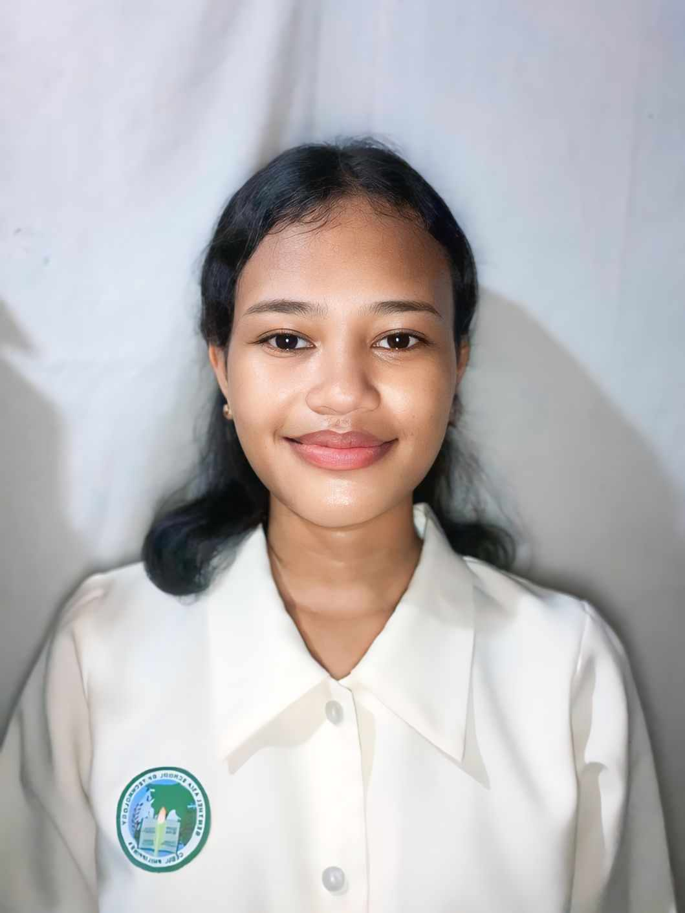

Date of Birth : September 2, 2007

Place of Birth : Mactan Doctor Hospital

Parent’s / Guardian’s Name : Rowena Y. Menguito

Postal Address :

E-mail Address : menguitojamaica628@gmail.com

Cellphone Number : 09694503906

Religion : Roman Catholic

Health Issues / Allergies : chicken

Hobbies / Past Time Activities : Skills / Talents : Badminton

Extra-curricular Activities in School : Support group / home companions : List your favourites : none

One word or object that describes yourself : How do you feel about school? :

It was fine at first, but now that I'm nearing the end of the school year, I can't take it anymore. school

Can be difficult or even stressful, but it is also a place full of chances. Experiences that mold the future.

What are your most memorable subject / class? Why? : Creative Writing because it allowed me to

Explore my imagination, express myself freely through storytelling, and develop a deeper appreciation

For language, all while being encouraged to think critically about the world around me.

What are your plans after Senior High School? : college

What is your career path? : to become a nurse

What is your philosophy in life? : My philosophy in life is simple yet meaningful: "Hard work, kindness, and perseverance lead to success.

Do you have plans to go abroad? If yes, where and why? : Yes, I do have plans to go to abroad in the

Future. One of the countries I would love to visit Japan learning Japanese and interested

Exploring different cultures.

What are your dreams and ambitions? : My dream is to become a compassionate and dedicated nurse who makes a positive impact on people’s lives. I have always admired the role of nurses in providing care, comfort, and support to patients during some of their most vulnerable moments. This has inspired me to pursue a career in nursing, where I can combine my passion for helping others with my desire to make a meaningful difference in the healthcare field.

How do you plan to achieve your ambitions and goals in life? : Achieving my ambition of becoming a compassionate and dedicated nurse requires hard work, determination, and a clear plan for success. While the journey may be challenging, I believe that with focus and perseverance, I can reach my goals and fulfill my dream of making a positive impact in the healthcare field.

What are your expectations and apprehensions for work immersion? : I believe that approaching my work immersion with a positive mindset will help me overcome these challenges.

**RULES AND REGULATIONS**

## Always on time

## Always tie your hair

## Wear proper uniform

## Do not sit while working hours

## Always greet the guest

## Always smile

## Always insert your polo

## Do not bring your phone inside

## Do not be late

## Wear your nameplate

## ESSAY BEFORE WORK IMMERSION

## Every work place has set of rules, whether you’re at the job of your dreams or at temporary training ground of your career path. First thing to remember is to know the nature and culture of the company. It’s important to dress appropriately for your job and make sure its clean and neat. Also, arriving on time to work demonstrates commitment your job. Everyone gets frustrated from time to time at work. Even if how much tired you are, it is always important to put a smile on your face to attract positivism. If you have difficulties in some things, don’t give up easily, take it as challenge for it will make you better, keep in mind that no one has ever succeeded because of laziness so always push yourself to the limits. If they coach you in an area, strive to improve. Make sure your always end up your day to learn something new.

## Keep in mind that at the workplace, strive to keep your communication professional. Furthermore, wear your smile always. Wear it before, during and after your job. As long as you conduct yourself with respect and confidence, work immersion can be fun and successful for you. Always see everyday as an opportunity towards your brighter future and don’t forget to ask god for guidance and protection, that you may be able to continue living tomorrow and the next days, always believe in yourself, because this is going to be your best weapon while you are living.

## I am looking forward to experience a job environment where I can apply my learnings into practice. I hope this work immersion will help improve my skills, knowledge and hopefully, I’ll be able to handle work and manage my time even if I’m under pressure.

## PICTURES WITH CAPTION

## 

## 

## Meeting

## 

## 

## Clean the ground area

## WORKING WITH THE SUPERVISOR

## 

## WORKING WITH THE TEAM

## 

## 

**JOURNAL 1**

**JOURNAL 2**

**JOURNAL 3**

**JOURNAL 4**

**JOURNAL 5**

**ACTIVITY 1**

**The Worker**

Work is on your way. Are you prepared to work? Do you have the potential, character, talents, and skills to take up the vigour of being a worker? What should you possess to become a good worker? How will you prepare for work immersion?

-To become an excellent worker, you must have a few crucial characteristics. First, discipline and accountability are essential. Employers respect employees that are prompt, dependable, and dedicated to their jobs. Second, adaptability and a willingness to learn are crucial since workplaces are continuously changing, and being open to new ideas and experiences can lead to advancement. Third, strong communication and cooperation abilities aid in developing positive relationships with coworkers, making it simpler to collaborate and achieve mutual goals. Finally, a positive attitude and work ethic distinguish outstanding employees from average ones, as devotion and tenacity frequently result in success.

establishing personal objectives for work immersion, including acquiring a new skill, becoming more professional, or boosting confidence, can help give the experience greater significance. Last but not least, the job immersion experience will be more fruitful if you have the proper mindset—being willing to learn, receptive to criticism, and prepared to take on challenges.

### ACTIVITY 2

After the pre-immersion orientation, list the Do’s and Don’ts employed in the workplace you are assigned.

|  |  |
| --- | --- |
| **DO’s** | **DON’Ts** |
| 1. Always on time | Do not be late |
| 1. Tie your hair | Do not sit while working hours |
| 1. Wear your nameplate | Do not bring your phone inside the company |
| 1. Always insert your polo shirt |  |
| 1. Always smile |  |
| 1. Always greet the guest |  |
| 7. |  |
| 8. |  |
| 9. |  |
| 10. |  |
| 11. |  |
| 12. |  |
| 13. |  |
| 14. |  |
| 15. |  |

###### Reflection

1. **Do you agree to the company’s policy guidelines, rules and agreement? Support your answer.**

Yes, because it shows discipline, commitment, and respect for workplace structure and to make sure that it will leave an good memories of those guest who came.

###### Was there a rule that you think is not acceptable to you? Why?

No, all of the rules are acceptable it can help you to be a better worker someday.

**ACTIVITY 3**

# CONFIDENTIALITY IN THE WORKPLACE

Privacy of the guest

Private matters of the company

Guest information

Employee information

Financial and business data

Security and safety

Internal communication

**ACTIVITY 4**

**PROBLEMS AND CHALLENGES ENCOUNTERED DURING WORK IMMERSION**

Another issue is lack of experience and technical skills. Since work immersion is designed for students, many enter the workplace with limited practical knowledge. Tasks assigned to them may seem difficult at first, and mistakes are inevitable. This can lead to feelings of self-doubt or frustration. However, with patience and willingness to learn, students can gradually improve and gain confidence in their abilities. Time management is also a major challenge. Balancing work immersion with school requirements and personal responsibilities can be stressful. Students may struggle with completing assigned tasks on time, especially if they are unfamiliar with workplace expectations. Developing time management skills and learning how to prioritize tasks can help overcome this challenge. Both mental and physical, may be an issue. Exhaustion can result from long workdays, difficult assignments, and the pressure to perform well. Stress or burnout can strike certain students, particularly those who are not accustomed to set work schedules. Effective stress management techniques include taking brief pauses, remaining organized, and keeping an optimistic outlook. Work immersion is still a worthwhile experience that aids students in getting ready for their future employment in spite of these obstacles. Overcoming challenges in work fosters adaptability, resilience, and a strong work ethic. Students can transform obstacles into chances for development and achievement by remaining receptive to new information, asking mentors for advice, and consistently honing their abilities.

**ACTIVITY 5**

**Conflict Resolution**

Did you ever experience disagreement and conflict with co-workers? How did you handle the situation? How would you rate your skills in handling differences of opinion? Please give an example that illustrates that skill.

_

 Working in a housekeeping environment requires teamwork, communication, and coordination to ensure that tasks are completed efficiently. While cooperation is key, disagreements can still arise — especially when there are differences in work styles or priorities. I once experienced such a situation during a particularly busy day in our housekeeping team. During a hotel event, our team was assigned to prepare several rooms within a short period. I believed that we should focus on cleaning the rooms one by one to ensure each was spotless before moving to the next. However, my co-worker suggested that we divide the tasks — one person would clean the bathrooms in all the rooms first, while another would handle vacuuming and dusting. At first, I disagreed with this approach because I felt it might cause confusion and lead to incomplete tasks. However, instead of arguing, I calmly shared my concern with my co-worker, explaining that our priority should be ensuring each room is guest-ready without missing details. My co-worker explained that their method had worked well in the past, especially when time was limited. Recognizing the urgency of the situation, I suggested a compromise — we agreed to divide the tasks but decided to double-check each room together before moving on. This way, we combined speed with quality control. The result was a smooth and efficient cleaning process that satisfied both our expectations and the hotel’s standards. Through this experience, I learned that communication, compromise, and teamwork are essential when resolving conflicts. By calmly discussing the issue instead of insisting on my way, I was able to understand my co-worker’s perspective and work with them to find a solution that benefited everyone.

**ACTIVITY 7**

**JOB INTERVIEW**

A job interview is an interview consisting of a conversation between a job applicant and a representative of an employer which is conducted to assess whether the applicant should be hired. How you answer questions during job interview can have a big impact on you being hired or accepted as a work immerse. Jot down questions that you have come across during your first dialogue with the partner-industry work supervisor or head of office you will be assigned.

A job interview is an essential step in the hiring process, where an employer evaluates an applicant’s skills, attitude, and readiness for the role. During my first dialogue with the partner-industry work supervisor for my upcoming work immersion, I encountered several important questions that gave me a better understanding of what employers expect from potential trainees. The first question I was asked was, "Can you tell me about yourself?" This allowed me to introduce myself, share my educational background, and highlight my interests and skills relevant to the role. I realized that this question is crucial in creating a positive first impression.

**ACTIVITY 8**

**Mock Job Interview**

* During the conduct of the mock job interview, do you think you did well?

During the mock job interview, I believe I performed reasonably well, but there are still areas where I can improve. I felt confident when introducing myself, as I had prepared key points about my background, skills, and goals. I maintained good eye contact, spoke clearly, and tried to express my answers with confidence.

* What are the areas that you think you are good at and areas that needed to be improved?

I felt well-prepared, as I had anticipated several common interview questions and practiced my responses. This allowed me to answer with confidence and structure my thoughts effectively. Despite feeling prepared, I noticed moments of nervousness, especially when answering questions I didn’t expect. Learning to stay calm and composed under pressure is something I aim to improve.

* Are you more confident now to answer during job interview?

I believe that with continued practice and a positive mindset, I can confidently present myself as a capable and determined applicant in future interviews.

**ACTIVITY 9**

**Report on Activities Performed**

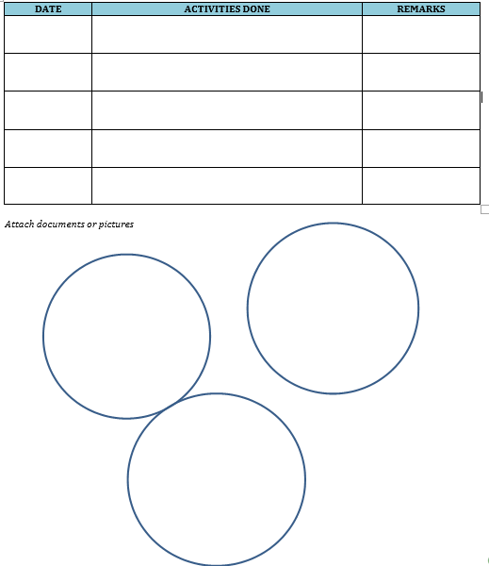s

***3/7/2025 beddings All beedings change***

***Trash successfully***

***3/10/2025 segregation of trash segregate***

***3/20/2025 General cleaning the VIP room VIP room cleaned***

***Swept and tidied***

***3/26/2025 cleaned the ground area***

***2/4/2025 Completed the bayanihan Successful***

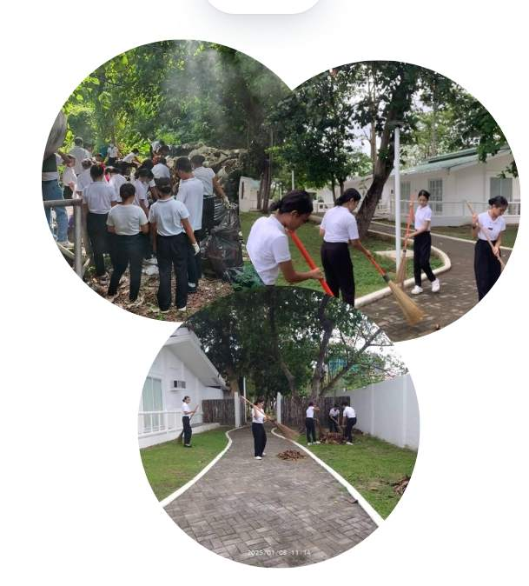

**ACTIVITY 10**

**Post- Immersion**

*Dear students you are now on the final stretch of your work immersion course. At this juncture you need to revisit the things that have been done in the past few days. What are the events that are memorable to you, what are the key learning’s that you have achieved and lastly you need to evaluate if the experienced gave you more confidence to face what lies ahead.*

**Make a collage of your work experience**

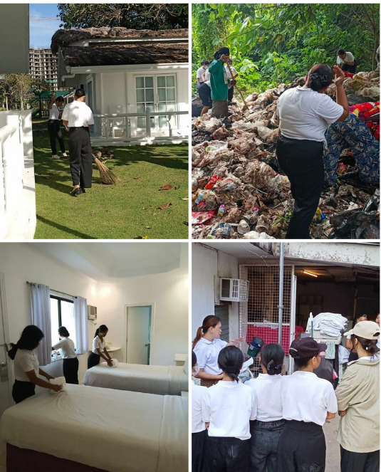

**WORK IMMERSION HIGHLIGHTS**

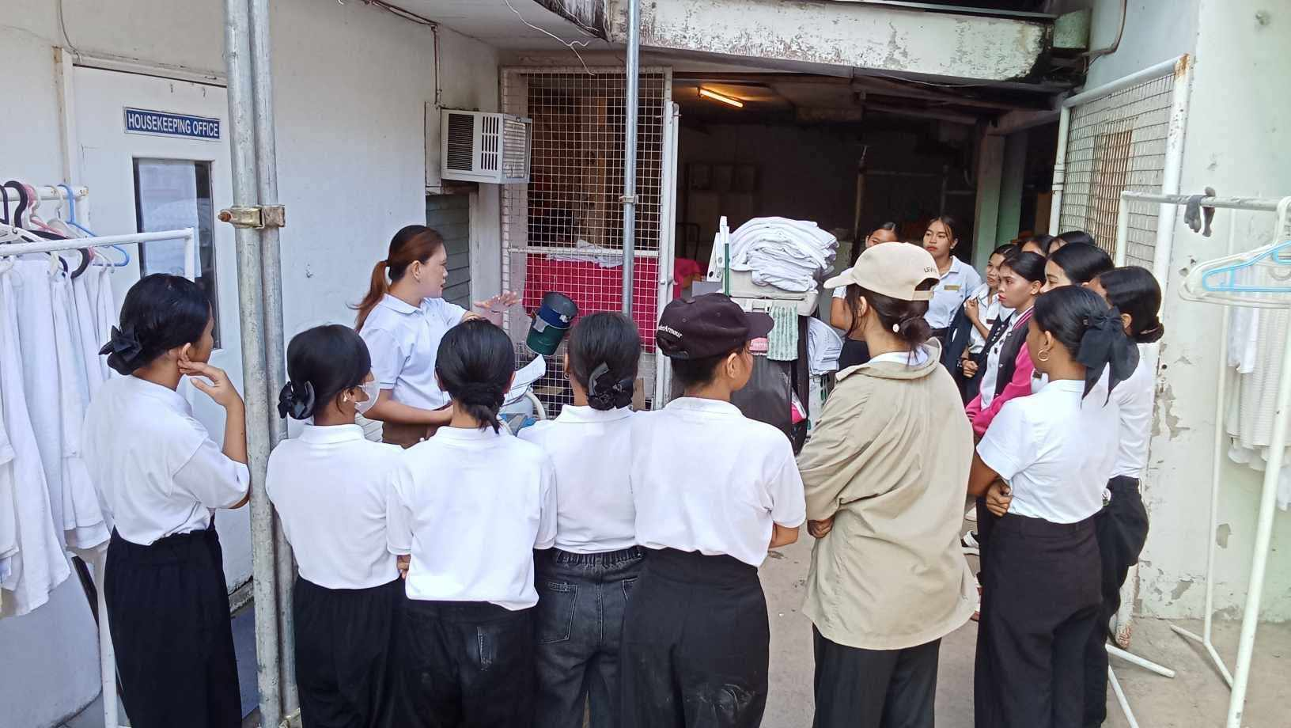

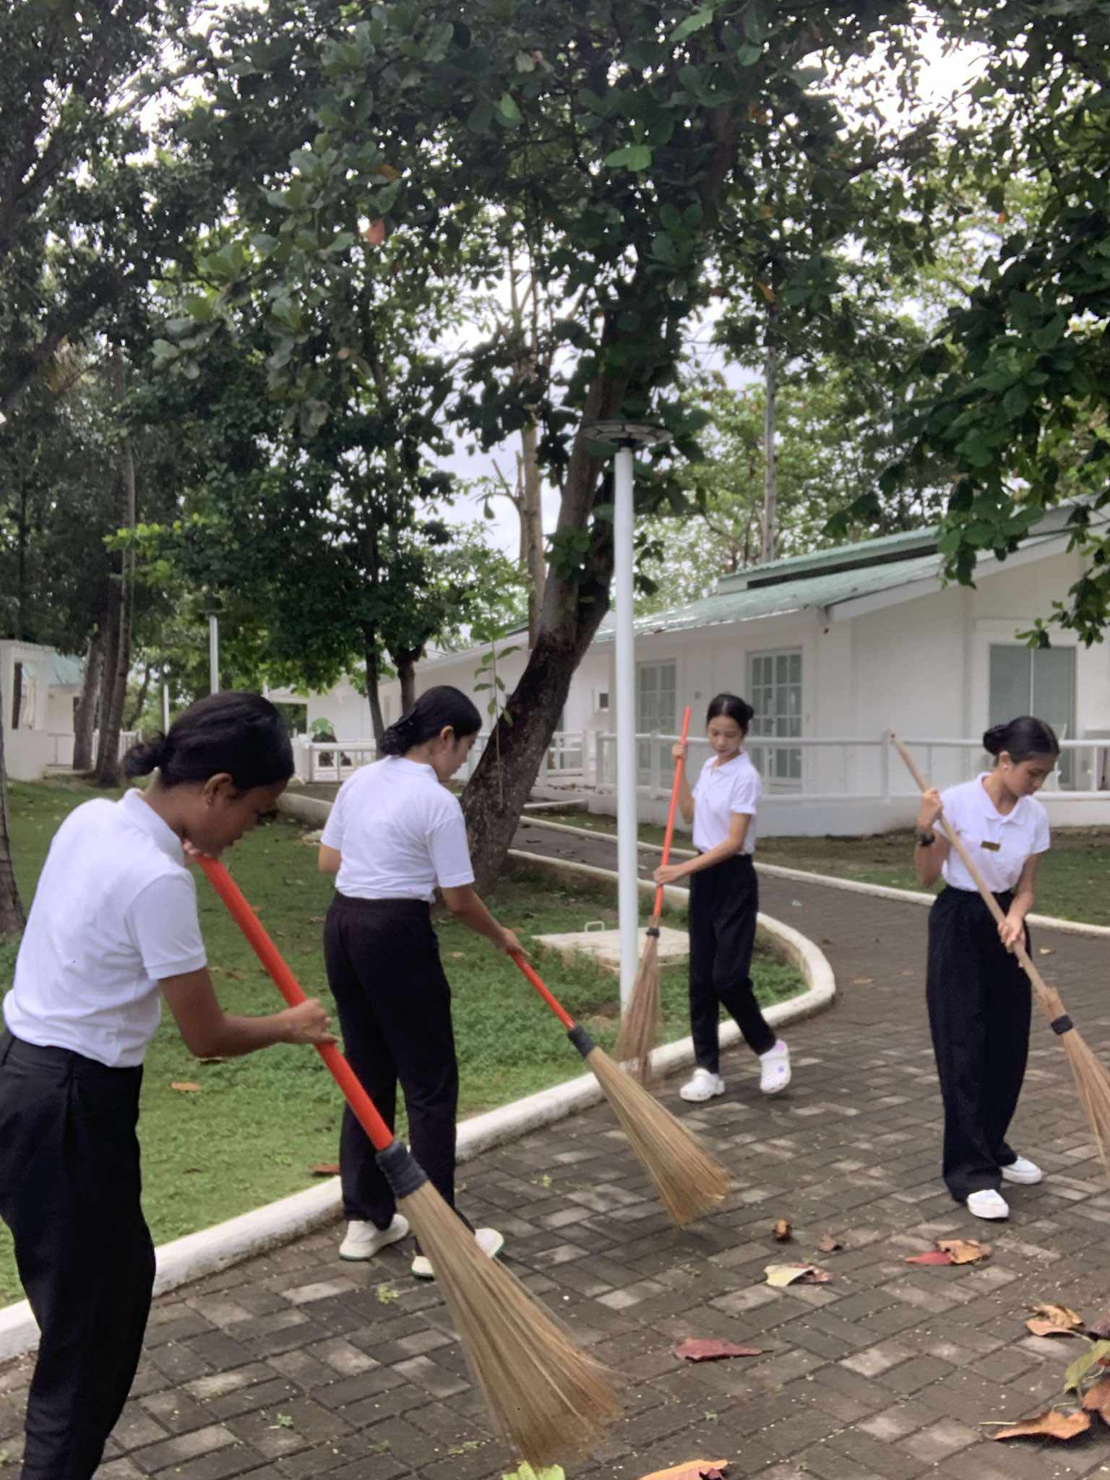

**MY REFLECTIONS**

How did the experience change me as a person, and how will it help me in the future.

The experience also helped me develop self-awareness. By reflecting on my strengths and areas for improvement, I became more conscious of my abilities and the things I need to work on. This mindset of continuous self-improvement will help me grow as an individual and prepare me for future challenges. Looking ahead, the lessons I learned from the mock interview will be invaluable. In the future, whether I apply for a part-time job, an internship, or a full-time career, I will feel more prepared and confident in my abilities. These insights will give me a competitive edge in the job market and help me secure better opportunities. this experience has shaped me into a more confident, self-aware, and professional individual. It has given me the tools to navigate the professional world with assurance, helping me take a step closer to achieving my career goals.

**DAILY TIME RECORD (DTR)**

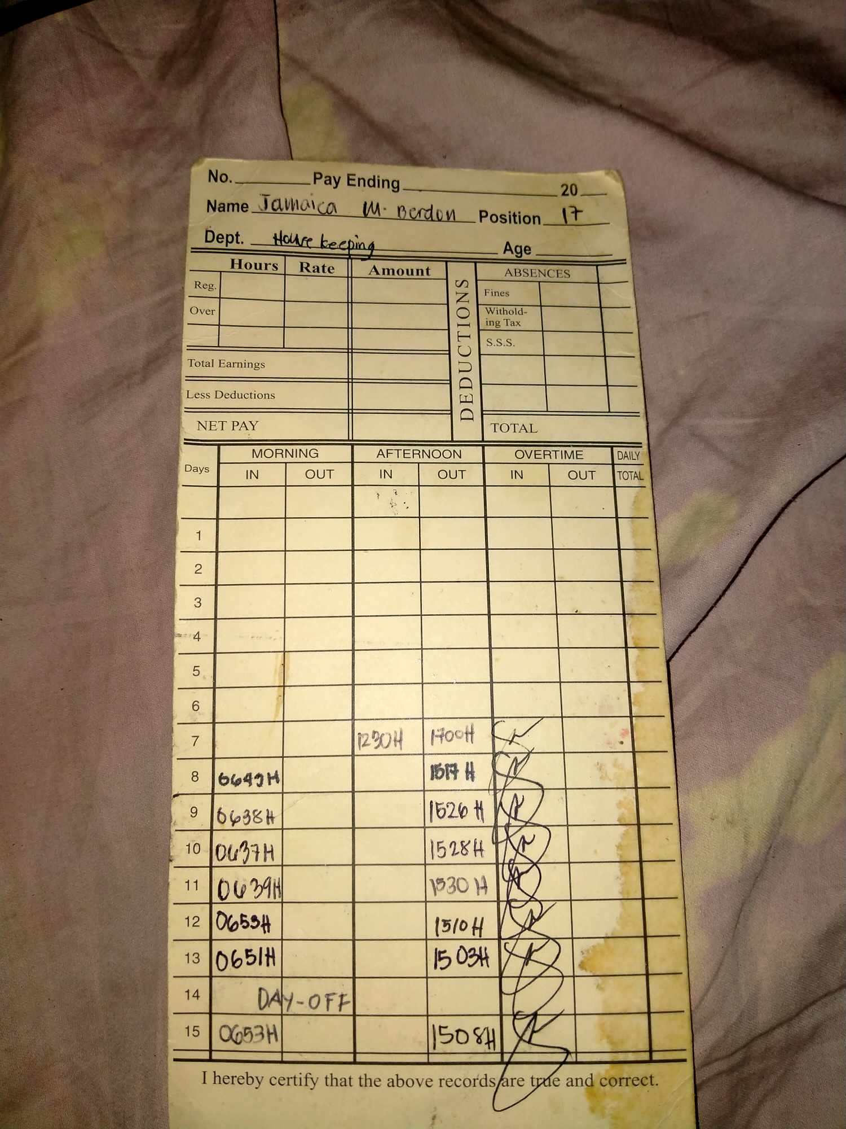

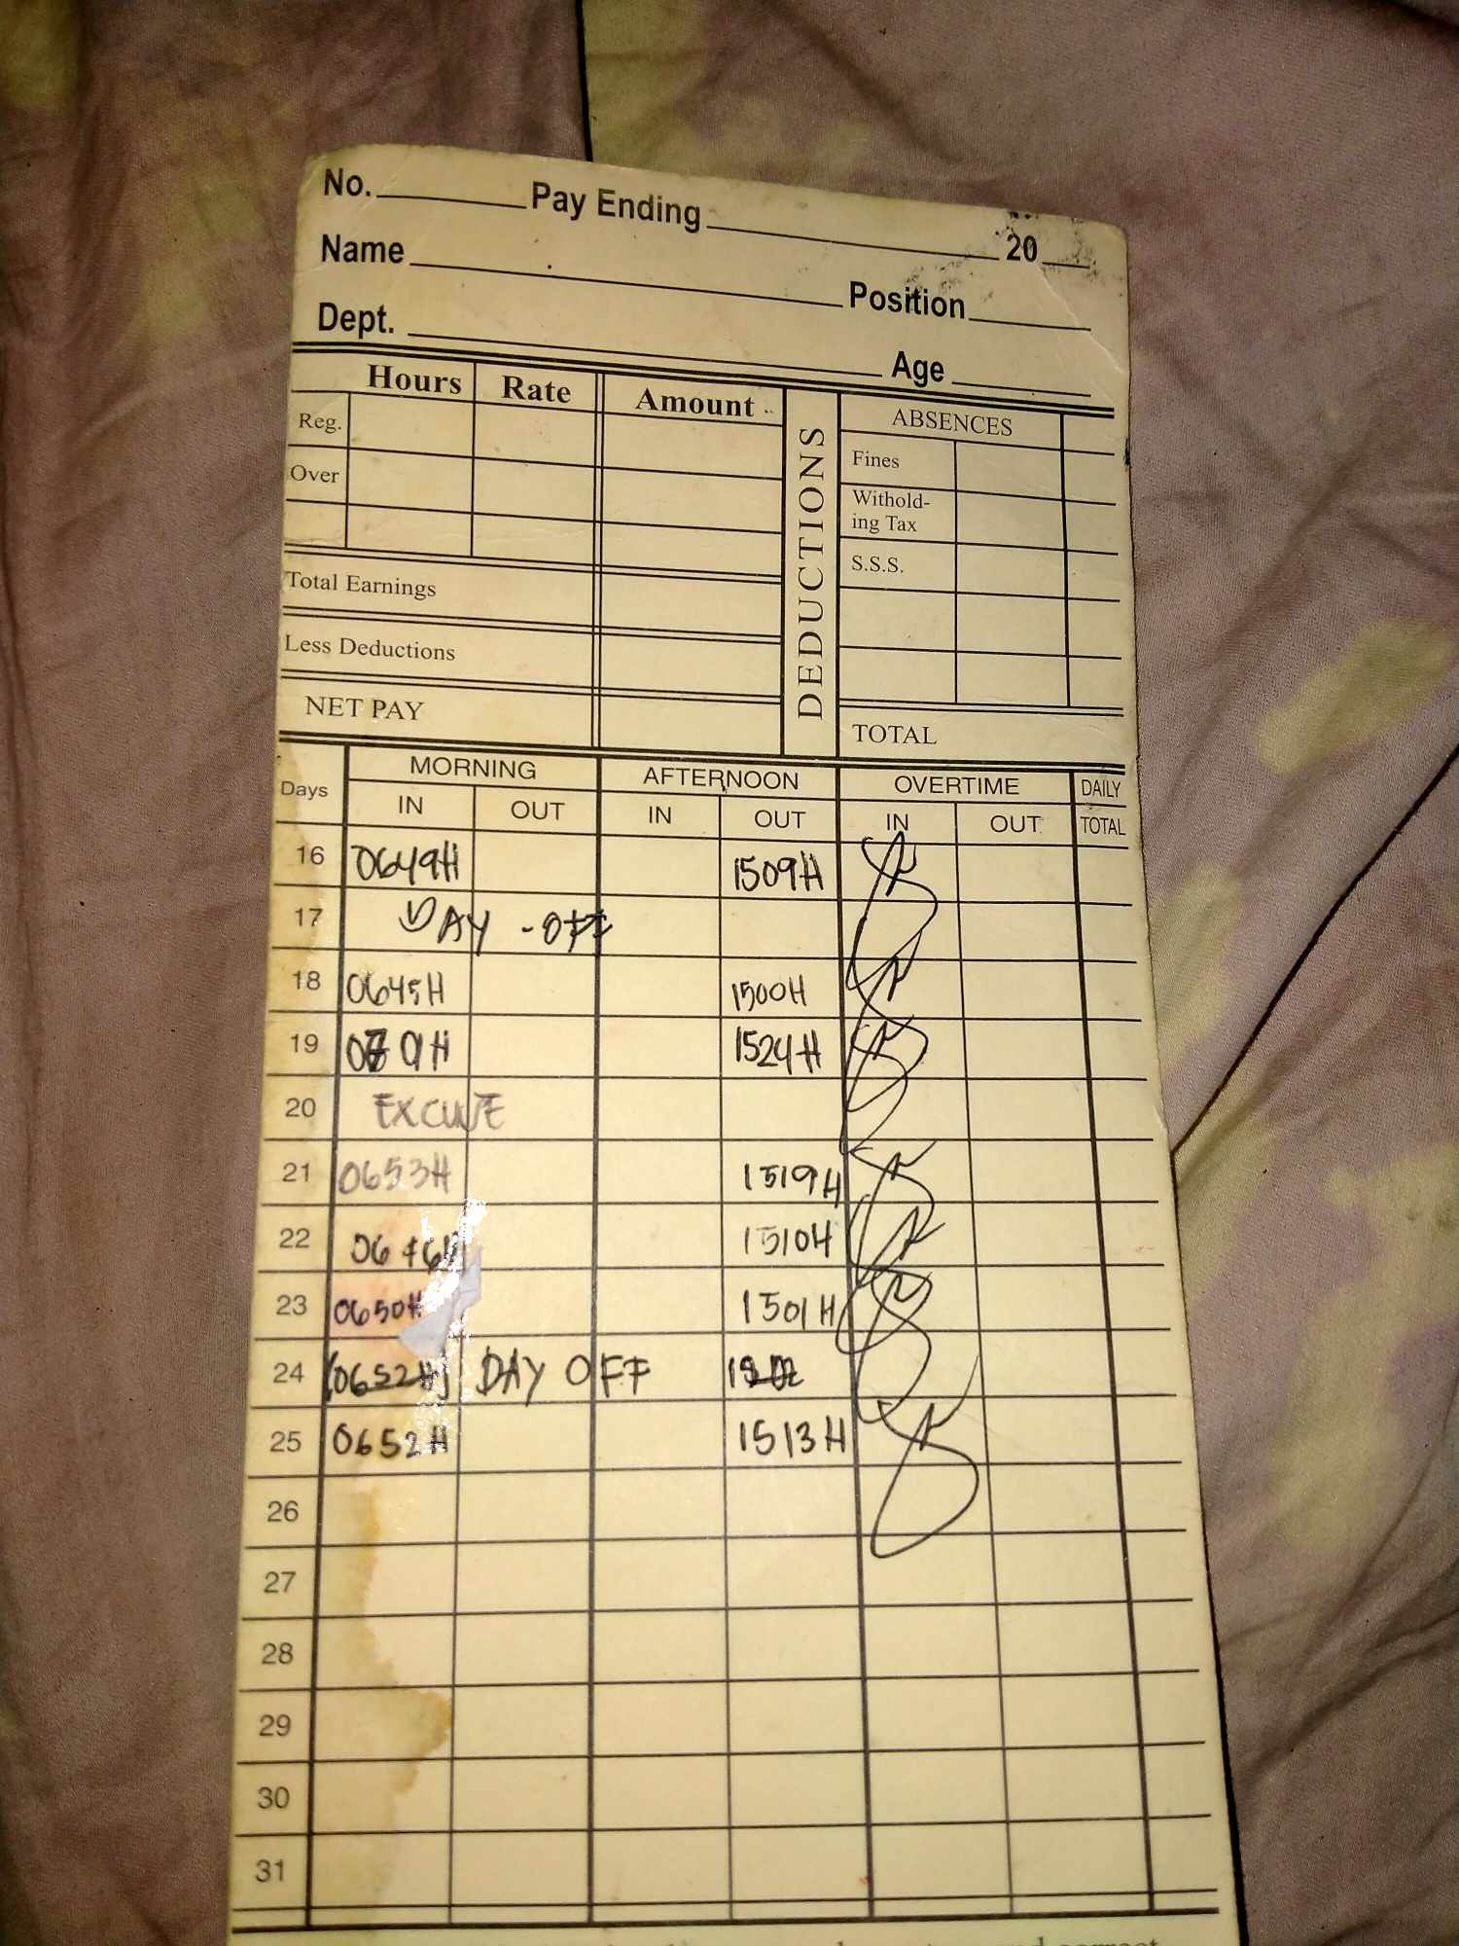

**STUDENT’S NAMEPLATE**

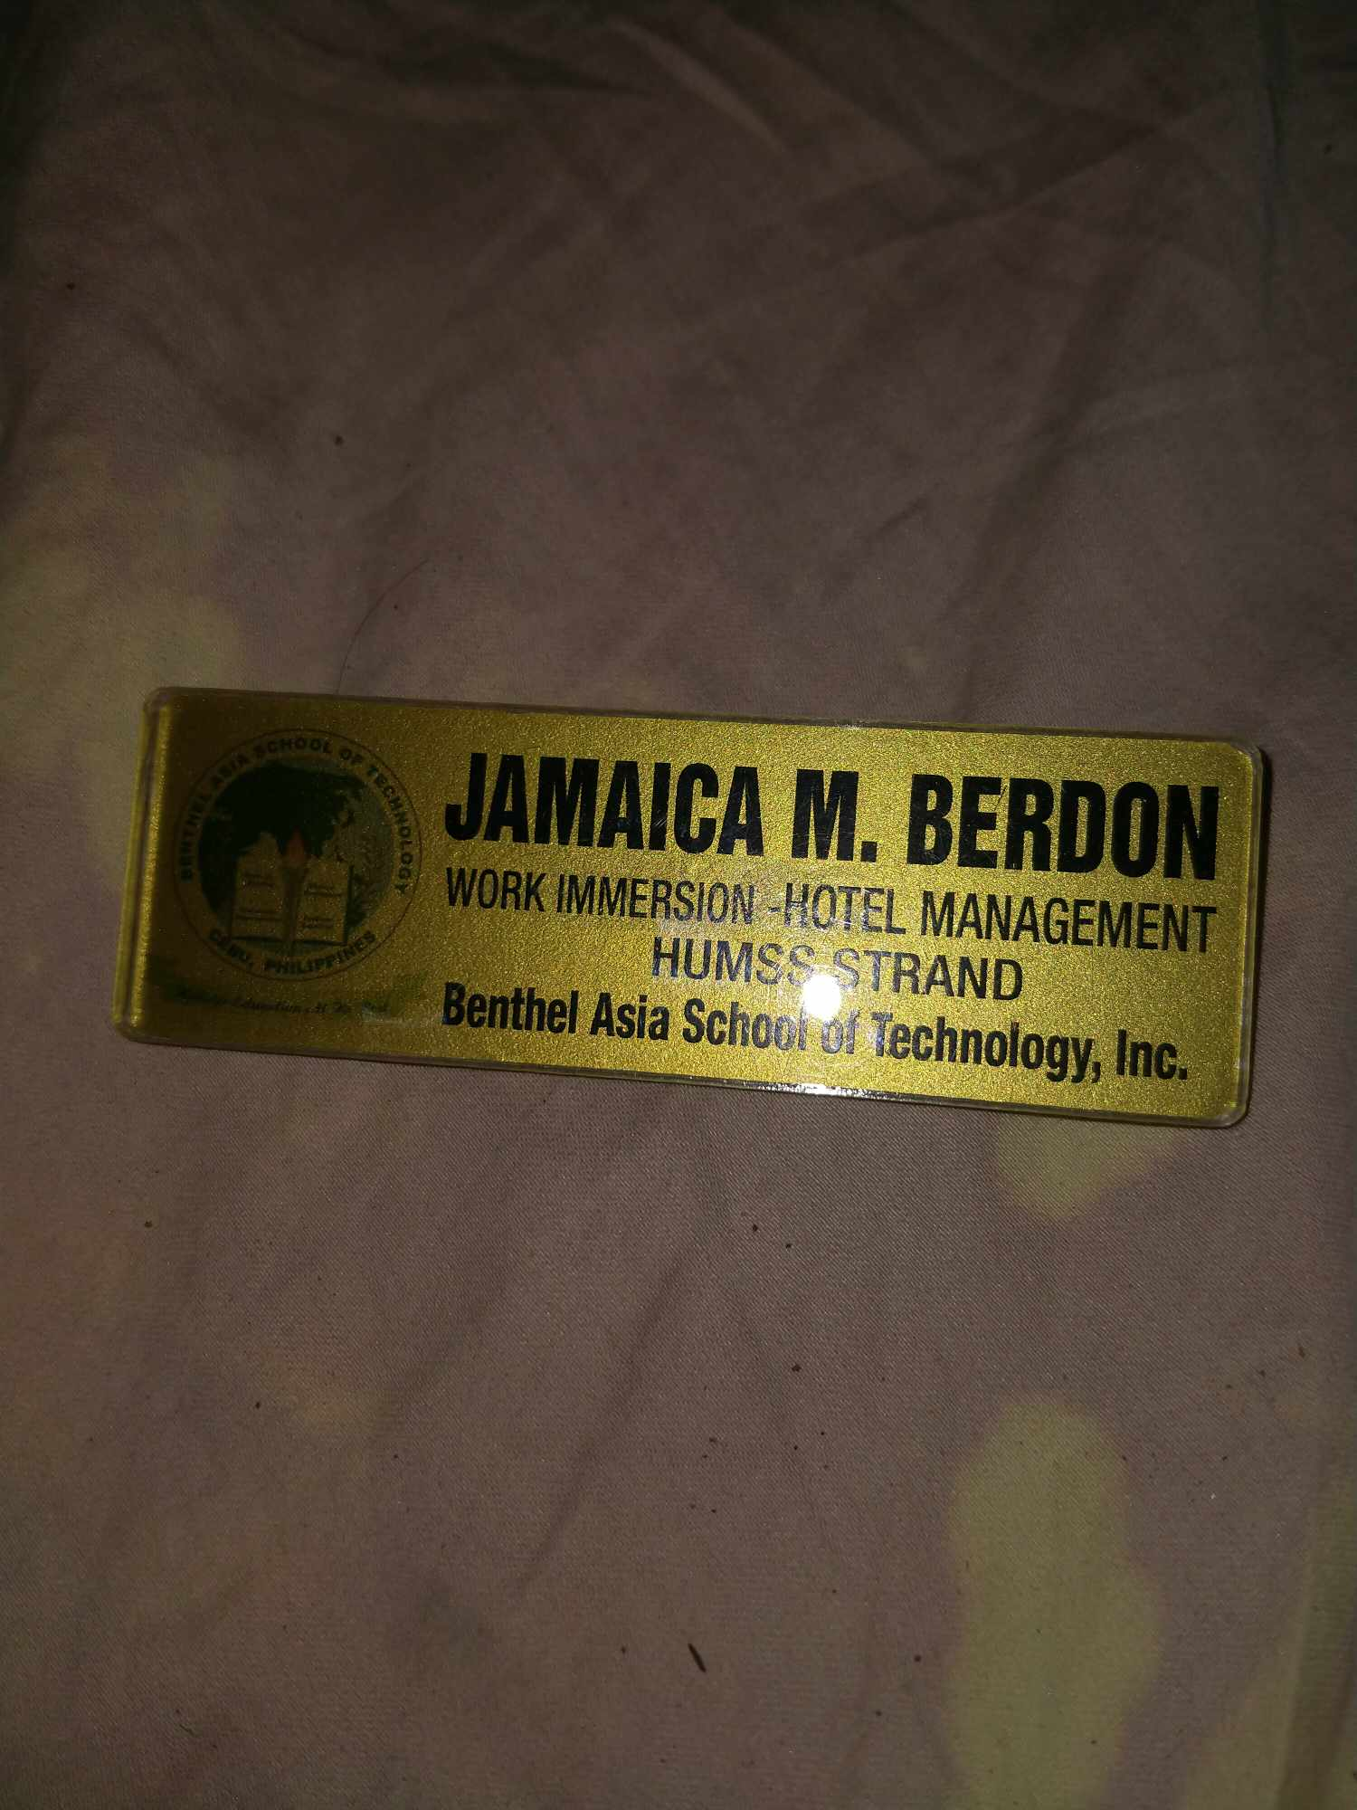

**EVALUATION SHEET**

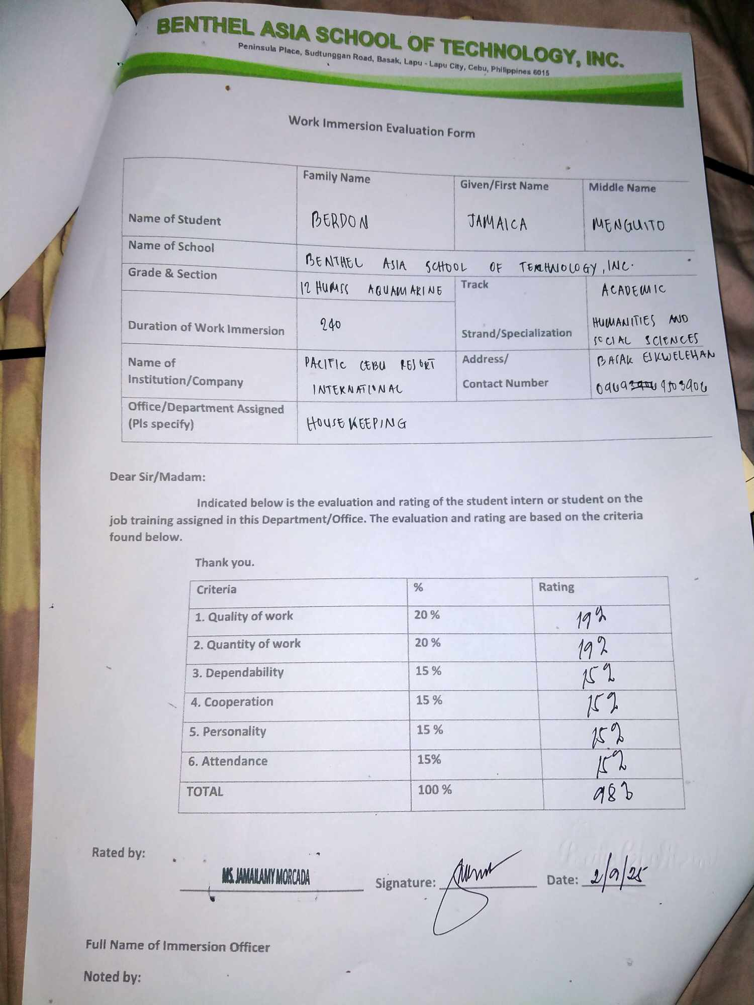

**COMPLETION CERTIFICATE**

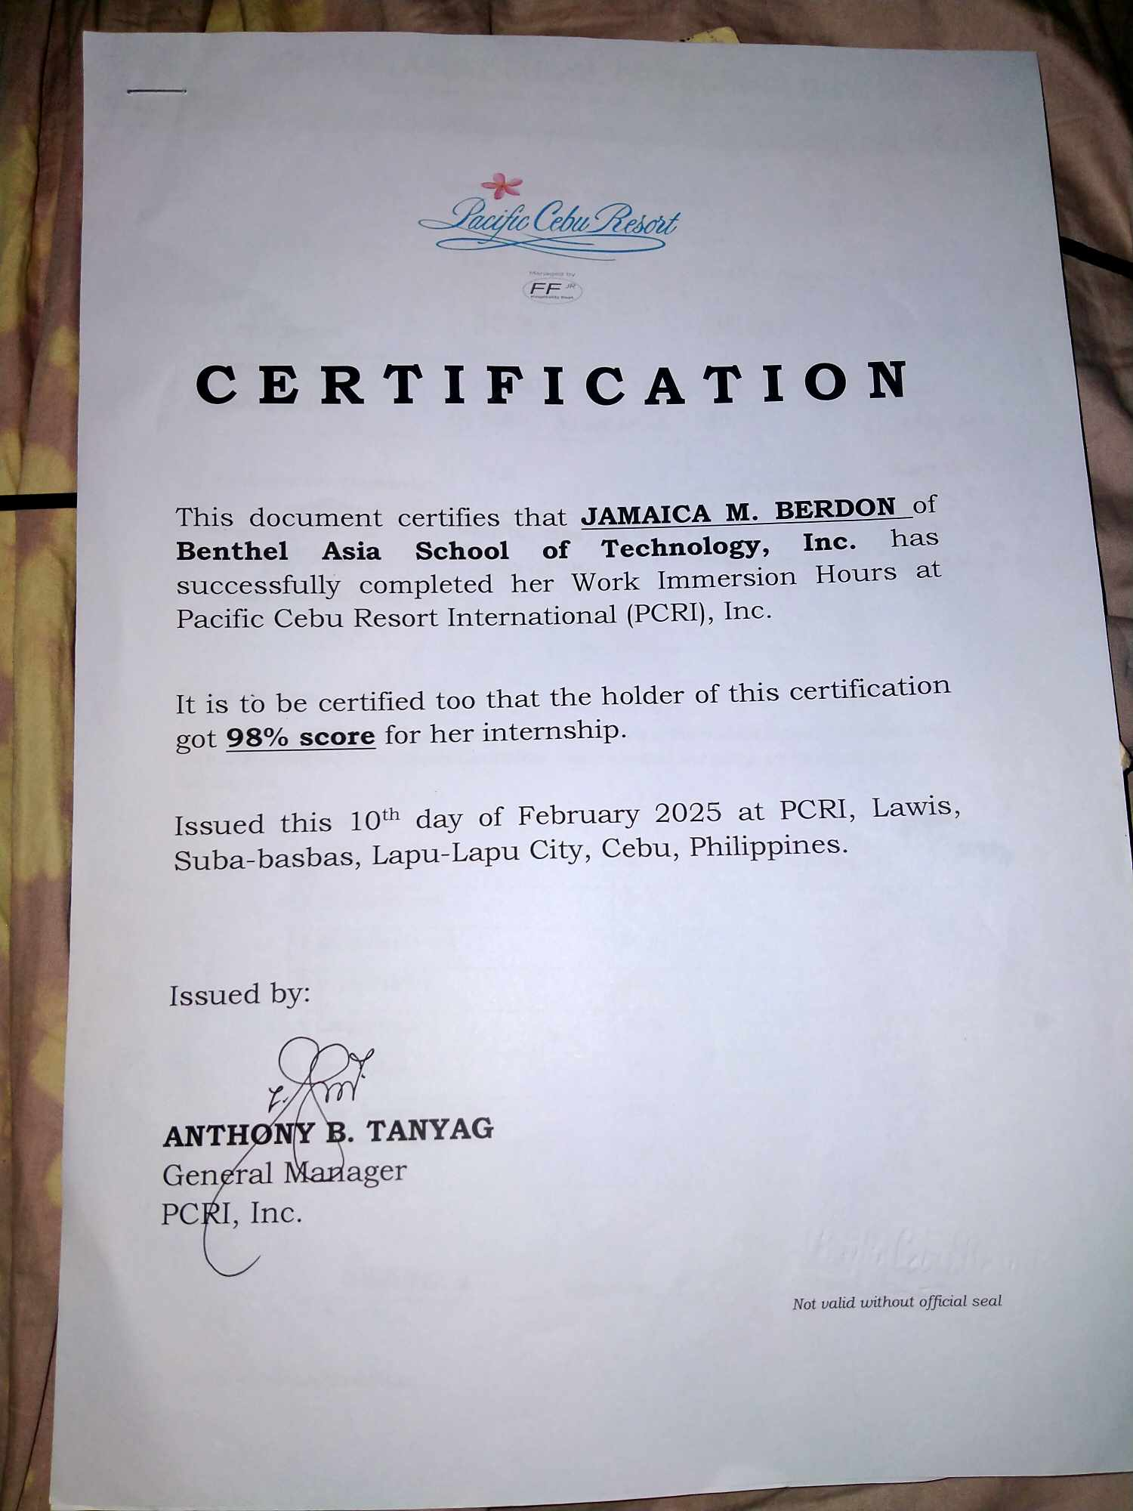

**RESUME BEFORE WORK IMMERSION**

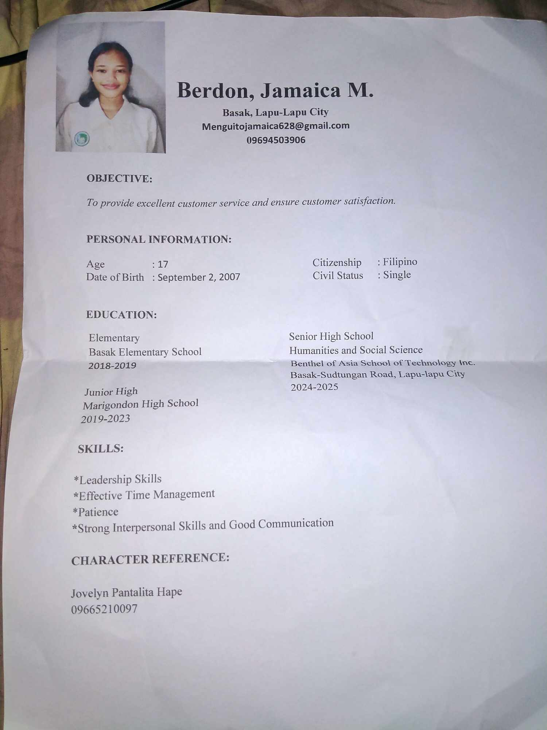

**APPLICATION LETTER**

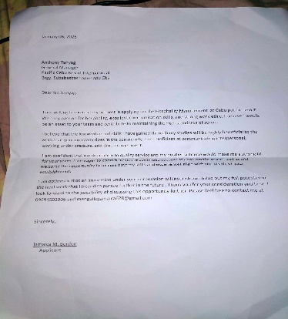



**RESUME AFTER WORK IMMERSION**

**PARENT’S CONSENT AND WAIVER**

**COLLAGE OF MY SENIOR HIGH SCHOOL EXPERIENCE**

